Microsoft Windows [Version 10.0.17134.48]

(c) 2018 Microsoft Corporation. Alle rechten voorbehouden.

N:\>c:

cd Mysandbox\docauto

C:\MySandbox\docauto>C:\Users\vth\Documents\docauto\docauto\Scripts\activate

(docauto) C:\MySandbox\docauto>minigui

'minigui' is not recognized as an internal or external command,

operable program or batch file.

(docauto) C:\MySandbox\docauto>minigui.py

'minigui.py' is not recognized as an internal or external command,

operable program or batch file.

(docauto) C:\MySandbox\docauto>python minigui.py

python: can't open file 'minigui.py': [Errno 2] No such file or directory

(docauto) C:\MySandbox\docauto>python minigui.pyw

-- Updating dictionaries --

Source: Excel Spreadsheet

Reading Excel file...DONE!

Writing temp file...DONE!

Traceback (most recent call last):

File "minigui.pyw", line 14, in <module>

from projects.projects import Project, project_structure

File "C:\MySandbox\docauto\projects\projects.py", line 7, in <module>

from certtool import CertTool

File "C:\MySandbox\docauto\projects\certtool.py", line 19, in <module>

class CertTool:

File "C:\MySandbox\docauto\projects\certtool.py", line 22, in CertTool

supported_certificates = CertificateDispatcher().supported_certificates

File "C:\MySandbox\docauto\pycerts\certs.py", line 1580, in __init__

self._update_dicts()

File "C:\MySandbox\docauto\pycerts\certs.py", line 1720, in _update_dicts

if dicts_manager.differ():

File "C:\MySandbox\docauto\pycerts\read_dicts.py", line 472, in differ

with open(self.out_python_dict, 'r') as old_file:

IOError: [Errno 2] No such file or directory: 'C:/users/pgo/Documents/docauto\\dictionaries.py'

(docauto) C:\MySandbox\docauto>python minigui.pyw

-- Updating dictionaries --

Source: Excel Spreadsheet

Reading Excel file...DONE!

Writing temp file...DONE!

Creating new configuration file...DONE!

Opening project folder ...

(docauto) C:\MySandbox\docauto>python mk_project.py

-- Updating dictionaries --

Source: Excel Spreadsheet

Reading Excel file...DONE!

Writing temp file...DONE!

Skipping not required dictionary update.

usage: mk_project.py [-h] [-t TYPE] [-n] [-l LOCATION] [-c COUNTRY]

[--lang [LANG [LANG ...]]]

code customer desc

mk_project.py: error: too few arguments

(docauto) C:\MySandbox\docauto>python mk_project.py rgo180010 SBAT "repair speedoscope" -l SINT-DENIJS-WESTREM -c Belgie --lang NL

C:\MySandbox\docauto>python mk_project.py rgo180013 SBAT "repair speedoscope" -l SINT-DENIJS-WESTREM -c Belgie --lang NL

-- Updating dictionaries –

Source: Excel Spreadsheet

Reading Excel file...DONE!

Writing temp file...DONE!

Skipping not required dictionary update.

Project type automatically assignated to 'NODOCS'.

Created project main folder: T:\_DOC\RGO180010 - SBAT_repair speedoscope

Creating NODOCS data structures...DONE!

Populating NODOCS data structures...DONE!

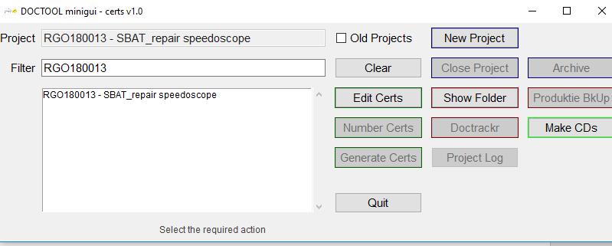

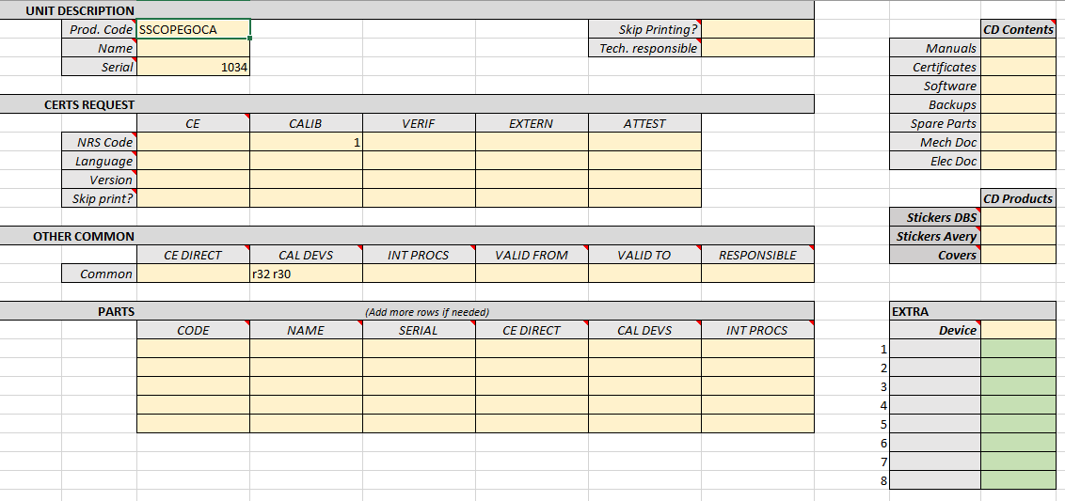

Invullen excel en meetmiddelen en saven

Genreate certs via gui ofwel manueel via cmd door

(docauto) C:\MySandbox\docauto>python mk_pycerts.py RGO180010

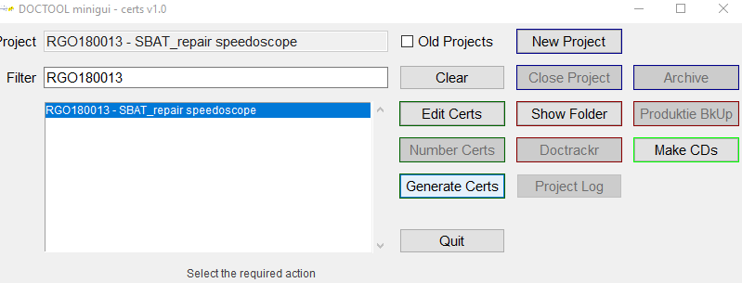

Traceback (most recent call last):

File "C:\MySandbox\docauto\minigui.pyw", line 14, in <module>

from projects.projects import Project, project_structure

File "C:\MySandbox\docauto\projects\projects.py", line 7, in <module>

from certtool import CertTool

File "C:\MySandbox\docauto\projects\certtool.py", line 6, in <module>

from openpyxl import load_workbook

ImportError: No module named openpyxl

Traceback (most recent call last):

File "mk_project.py", line 78, in <module>

subprocess.check_call(minigui_cmd)

File "c:\python27\Lib\subprocess.py", line 190, in check_call

raise CalledProcessError(retcode, cmd)

subprocess.CalledProcessError: Command '"c:\Python27\python.exe" "C:\MySandbox\docauto\minigui.pyw" "RGO180010"' returned non-zero exit status 1

(docauto) C:\MySandbox\docauto>pip freeze

colorama==0.3.9

et-xmlfile==1.0.1

jdcal==1.3

lxml==4.2.1

nrsdb==0.1.3

openpyxl==2.4.0

Pillow==3.4.1

pymssql==2.1.3

python-docx==0.8.6

qrcode==5.3

six==1.11.0

(docauto) C:\MySandbox\docauto>python

Python 2.7.15 (v2.7.15:ca079a3ea3, Apr 30 2018, 16:30:26) [MSC v.1500 64 bit (AMD64)] on win32

Type "help", "copyright", "credits" or "license" for more information.

>>> import openpyxl

>>> quit

Use quit() or Ctrl-Z plus Return to exit

>>> quit()

(docauto) C:\MySandbox\docauto>python mk_project.py rgo180010 SBAT "repair speedoscope" -l SINT-DENIJS-WESTREM -c Belgie --lang NL

-- Updating dictionaries --

Source: Excel Spreadsheet

Reading Excel file...DONE!

Writing temp file...DONE!

Skipping not required dictionary update.

Project type automatically assignated to 'NODOCS'.

ERR: Project folder (or illegal file) already exists for project "RGO180010"

Should I remove the old structure? (Yes or No): y

Sorry, could not complete the task.

ERR: Project folder (or illegal file) already exists for project "RGO180010"

(docauto) C:\MySandbox\docauto>yes

'yes' is not recognized as an internal or external command,

operable program or batch file.

(docauto) C:\MySandbox\docauto>python mk_project.py rgo180010 SBAT "repair speedoscope" -l SINT-DENIJS-WESTREM -c Belgie --lang NL

-- Updating dictionaries --

Source: Excel Spreadsheet

Reading Excel file...DONE!

Writing temp file...DONE!

Skipping not required dictionary update.

Project type automatically assignated to 'NODOCS'.

ERR: Project folder (or illegal file) already exists for project "RGO180010"

Should I remove the old structure? (Yes or No): Yes

Are you sure you want to delete the full folder, subfolders and files? (YES or No): YES

You asked for it. No way back!

Deleting the RGO180010 project folder structure...DONE!

Created project main folder: T:\_DOC\RGO180010 - SBAT_repair speedoscope

Creating NODOCS data structures...DONE!

Populating NODOCS data structures...DONE!

Traceback (most recent call last):

File "mk_project.py", line 78, in <module>

subprocess.check_call(minigui_cmd)

File "c:\python27\Lib\subprocess.py", line 185, in check_call

retcode = call(*popenargs, **kwargs)

File "c:\python27\Lib\subprocess.py", line 172, in call

return Popen(*popenargs, **kwargs).wait()

File "c:\python27\Lib\subprocess.py", line 394, in __init__

errread, errwrite)

File "c:\python27\Lib\subprocess.py", line 644, in _execute_child

startupinfo)

WindowsError: [Error 2] Het systeem kan het opgegeven bestand niet vinden

(docauto) C:\MySandbox\docauto>python mk_project.py rgo180010 SBAT "repair speedoscope" -l SINT-DENIJS-WESTREM -c Belgie --lang NL

-- Updating dictionaries --

Source: Excel Spreadsheet

Reading Excel file...DONE!

Writing temp file...DONE!

Skipping not required dictionary update.

Project type automatically assignated to 'NODOCS'.

ERR: Project folder (or illegal file) already exists for project "RGO180010"

Should I remove the old structure? (Yes or No): Yes

Are you sure you want to delete the full folder, subfolders and files? (YES or No): YES

You asked for it. No way back!

Deleting the RGO180010 project folder structure...DONE!

Created project main folder: T:\_DOC\RGO180010 - SBAT_repair speedoscope

Creating NODOCS data structures...DONE!

Populating NODOCS data structures...DONE!

-- Updating dictionaries --

Source: Excel Spreadsheet

Reading Excel file...DONE!

Writing temp file...DONE!

Skipping not required dictionary update.

Opening CERTTOOL for edition

Traceback (most recent call last):

File "mk_project.py", line 78, in <module>

subprocess.check_call(minigui_cmd)

File "c:\python27\Lib\subprocess.py", line 190, in check_call

raise CalledProcessError(retcode, cmd)

subprocess.CalledProcessError: Command '"python" "C:\MySandbox\docauto\minigui.pyw" "RGO180010"' returned non-zero exit status -805306369

(docauto) C:\MySandbox\docauto>python mk_pycerts.py

-- Updating dictionaries --

Source: Excel Spreadsheet

Reading Excel file...DONE!

Writing temp file...DONE!

Skipping not required dictionary update.

usage: mk_pycerts [-h] [-n] msoft_code

mk_pycerts: error: too few arguments

(docauto) C:\MySandbox\docauto>python mk_pycerts.py -h

-- Updating dictionaries --

Source: Excel Spreadsheet

Reading Excel file...DONE!

Writing temp file...DONE!

Skipping not required dictionary update.

usage: mk_pycerts [-h] [-n] msoft_code

Create certificates for the requested project

positional arguments:

msoft_code M-Soft project code

optional arguments:

-h, --help show this help message and exit

-n, --no_edition skip final document edition/printing

(docauto) C:\MySandbox\docauto>python mk_pycerts.py RGO180010

-- Updating dictionaries --

Source: Excel Spreadsheet

Reading Excel file...DONE!

Writing temp file...DONE!

Skipping not required dictionary update.

-- Updating dictionaries --

Source: Excel Spreadsheet

Reading Excel file...DONE!

Writing temp file...DONE!

Skipping not required dictionary update.

Saving 'T:/_DOC\_pycerts\RGO180010-D4N01_.docx' ... DONE!

Opening WORD documents sequentially for further edition and printing

(docauto) C:\MySandbox\docauto>python mk_pycerts.py RGO180010

-- Updating dictionaries --

Source: Excel Spreadsheet

Reading Excel file...DONE!

Writing temp file...DONE!

Skipping not required dictionary update.

-- Updating dictionaries --

Source: Excel Spreadsheet

Reading Excel file...DONE!

Writing temp file...DONE!

Skipping not required dictionary update.

Saving 'T:/_DOC\_pycerts\RGO180010-D4N01_.docx' ... DONE!

Opening WORD documents sequentially for further edition and printing

(docauto) C:\MySandbox\docauto>

(docauto) C:\MySandbox\docauto>c:\Python27\Tools\i18n\msgfmt.py C:\Users\PGO\Documents\docauto\pycerts\locale\cs_CZ\LC_MESSAGES\pycerts.po

(docauto) C:\MySandbox\docauto>c:\Python27\Tools\i18n\msgfmt.py C:\Users\PGO\Documents\docauto\pycerts\locale\de_DE\LC_MESSAGES\pycerts.po

(docauto) C:\MySandbox\docauto>c:\Python27\Tools\i18n\msgfmt.py C:\Users\PGO\Documents\docauto\pycerts\locale\es_ES\LC_MESSAGES\pycerts.po

(docauto) C:\MySandbox\docauto>c:\Python27\Tools\i18n\msgfmt.py C:\Users\PGO\Documents\docauto\pycerts\locale\fr_FR\LC_MESSAGES\pycerts.po

(docauto) C:\MySandbox\docauto>c:\Python27\Tools\i18n\msgfmt.py C:\Users\PGO\Documents\docauto\pycerts\locale\nl_BE\LC_MESSAGES\pycerts.po

(docauto) C:\MySandbox\docauto>C:\Users\vth\Documents\docauto\docauto\Scripts\python pycerts\locale\cz_CZ\LC_MESSAGES\pycerts.po

C:\Users\vth\Documents\docauto\docauto\Scripts\python: can't open file 'pycerts\locale\cz_CZ\LC_MESSAGES\pycerts.po': [Errno 2] No such file or directory

(docauto) C:\MySandbox\docauto>C:\Users\vth\Documents\docauto\docauto\Scripts\python pycerts\locale\cs_CZ\LC_MESSAGES\pycerts.po

File "pycerts\locale\cs_CZ\LC_MESSAGES\pycerts.po", line 5

msgid ""

^

SyntaxError: invalid syntax

(docauto) C:\MySandbox\docauto>C:\Users\vth\Documents\docauto\docauto\Scripts\python pycerts\locale\nl_BE\LC_MESSAGES\pycerts.po

File "pycerts\locale\nl_BE\LC_MESSAGES\pycerts.po", line 5

msgid ""

^

SyntaxError: invalid syntax

(docauto) C:\MySandbox\docauto>python pycerts\locale\nl_BE\LC_MESSAGES\pycerts.po

File "pycerts\locale\nl_BE\LC_MESSAGES\pycerts.po", line 5

msgid ""

^

SyntaxError: invalid syntax

(docauto) C:\MySandbox\docauto>c:\python27\python pycerts\locale\nl_BE\LC_MESSAGES\pycerts.po

File "pycerts\locale\nl_BE\LC_MESSAGES\pycerts.po", line 5

msgid ""

^

SyntaxError: invalid syntax

(docauto) C:\MySandbox\docauto>python mk_pycerts.py RGO180010

-- Updating dictionaries --

Source: Excel Spreadsheet

Reading Excel file...DONE!

Writing temp file...DONE!

Skipping not required dictionary update.

-- Updating dictionaries --

Source: Excel Spreadsheet

Reading Excel file...DONE!

Writing temp file...DONE!

Skipping not required dictionary update.

Saving 'T:/_DOC\_pycerts\RGO180010-D4N01_.docx' ... DONE!

Opening WORD documents sequentially for further edition and printing